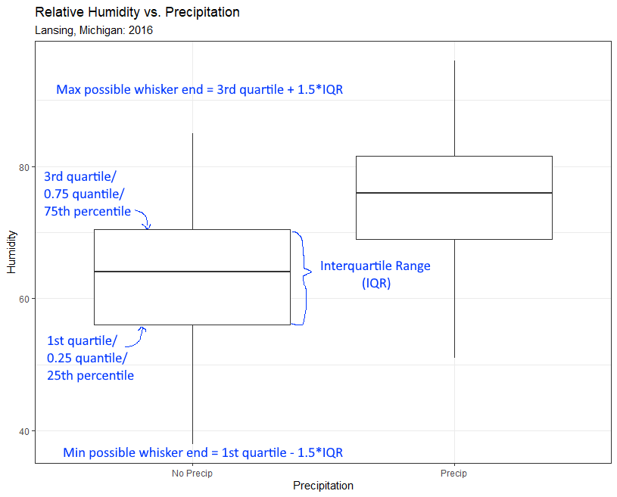

The multiplier 1.5 is the default value – but this is often changed to extend or contract the whiskers (in geom_boxplot() it is the subcomponent coef.

The min and max possible whiskers ends are (usually) not the actual whisker ends. The actual whisker end is the data point with the closest value to the possible whisker end without going beyond.

